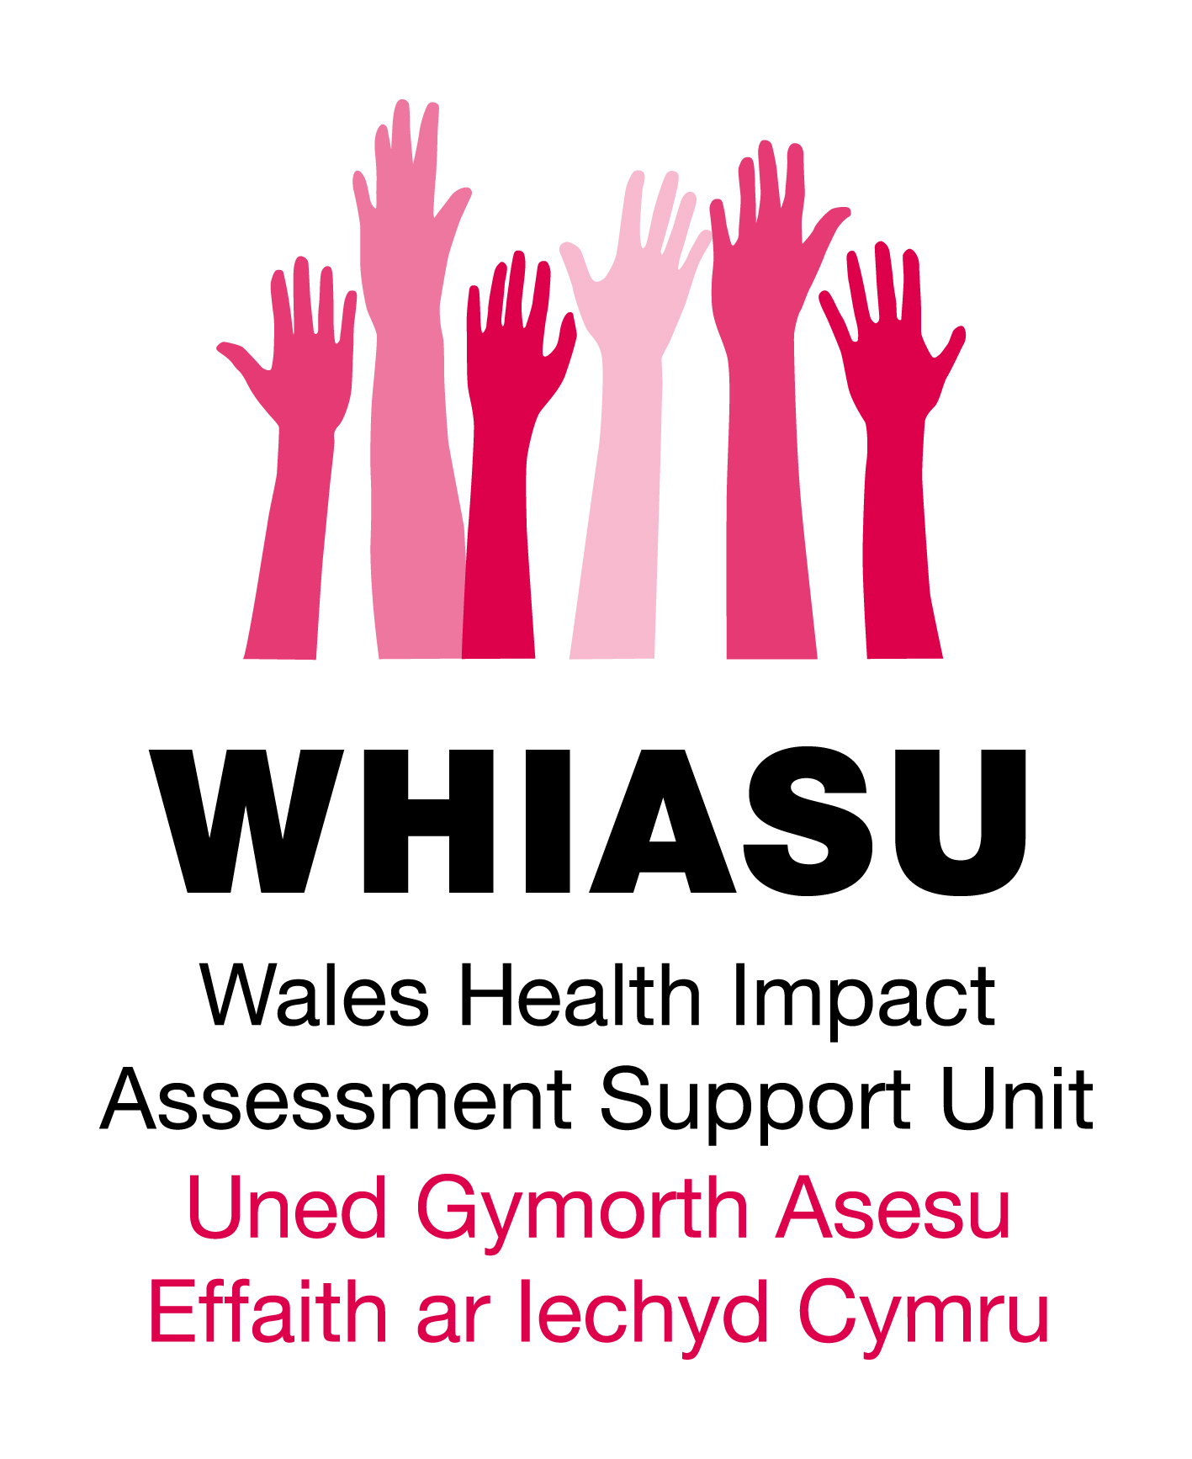

**Community Led HIA Case Study**

**Margam Opencast Mine**

The comprehensive health impact assessment examined the impact of the proposed extension to the Margam Opencast mine, located in South Wales. Residents of the villages bordering the existing opencast operations, which have been operation for many years, believe that the existing opencast working in the area had already had a negative impact on their health, and that the proposed extension would exacerbate this further. In addition residents were concerned about the cumulative effects of exposure to pollutants from other industries within the locality including a local steelworks.

The HIA arose from an approach made to WHIASU in early 2005 by a community member representing local residents who had formed an action group, PACT, to protest against the proposed extension. The HIA the planning application was being considered by two local authorities (Bridgend and Neath Port Talbot County Borough Councils). At the time of the HIA there was no statutory requirement for HIA to be undertaken on opencast proposals in Wales. The HIA was undertaken by WHIASU and the National Public Health Service for Wales (NPHS) on behalf of the Margam Opencast and Health Steering Group in December 2005.

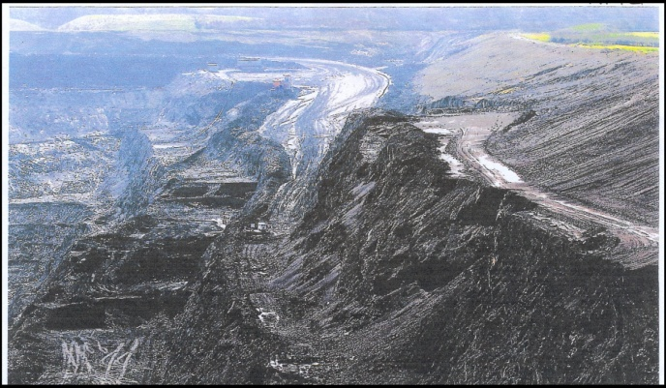**Partners involved**

The HIA involved a range of partners who were involved in a variety of capacities; as advisors, researchers, steering group members, concerned citizens, members of community groups and HIA and health inequalities specialists. These included by two local authorities (Bridgend and Neath Port Talbot County Borough Councils), Environmental Health, the National Public Health Service (now Public Health Wales), local residents and WHIASU. The HIA was highly participatory in nature, with members of the community being involved in focus groups, public meetings, the steering group and in determining the health impacts to be assessed.

**Summary of key potential health impacts**

***Nuisance dust***: 200mg per square metre is recognised as a threshold, but levels that comply with this figure are not now considered acceptable, with coal dust in excess of 80mg per sq meter per day likely to generate complaints. 80 mg was exceeded at the site at times and came close to this limit, particularly in the summer months. Residents reported dust deposits on homes, being able to smell dust in the air and impact on enjoyment of the outdoors. Concerns were also raised that dust may be causing eye and respiratory problems or aggravating existing conditions.

***Particulates****:* PM10 levels at the site were within allowable levels and there is no current requirement for smaller particles (PM 2.5) to be measured separately. Though the number of PM10 exceedences are within allowable limits, it does mean that residents have at times been exposed to health damaging levels of particulates (although these cannot necessarily be solely attributed to the opencast site).

***Stress, anxiety and depression:***Whilst there is no direct evidence that demands on primary care would increase as a result of the development, it is possible there may be an increase in stress related consultations with residents reporting they were suffering stress as a result of worries about the impacts of the development. It was also reported that the planning process itself had caused stress. Belief of exposure to harmful or toxic substances was identified as a predictor of poor reported health regardless of the actual toxicity of the site.

***Physical activity:***The presence of green space acts as a motivator for physical activity. An increase in opencast activity is likely to lead to restrictions in children playing outdoors due to health concerns, and the perceived attractiveness of the area is also likely to lead to reduced use of the outdoors for walking for recreation or exercise. Noise, dust, removal of footpaths and unpleasantness of the view were all cited by residents as reasons for reduced outdoor activities.

***Local Economy****:* Impact on existing businesses: likely to be a negative effect on local businesses (particularly in terms of tourism) and it was agreed that there was no economic benefit for local people from the current site.

***Noise and Vibration****:* The geography of the site would mean that workings would be closer to residential dwellings and as such would cause greater noise disturbance to residents. Local schools may also be affected by noise. Noise pollution has been found to contribute to the prevalence of cardiovascular disease, possible respiratory impairment and psychological symptoms and use of psychotropic medicine. Residents are already experiencing noise which is impacting upon a ‘normal’ life, including keeping windows closed and sleep disturbance. Residents also reported that vibration from the site can already be felt in some homes.

***Light pollution:***Outside of working hours some illumination would be required on the site for safety and security reasons. This light pollution may contribute to sleep disturbance which would affect more homes if the proposed extension was to go ahead.

***Loss of amenity and Visual Impact:***Loss of amenity was raised in relation to walking, cycling, horse riding and other outdoor pursuits. HIA recognises that the nature of the development of certain to have a negative aesthetic impact as the area of housing that would be affected currently has a view of fields and woodland, and the proximity to housing and topography of the land would prevent effective screening.

***Effect on property and character of the neighbourhood:*** Communities around the development fear that property will be devalued and difficult to sell, and that they will be compelled to stay in an area which has totally changed in character (from rural/semi-rural to industrial).

**HIA recommendations**

The HIA concluded that the potential negative health impacts outweighed any positive impacts and in coming to a decision on the future of opencast mining in the area the HIA Steering Group recommended that three principles should prevail:

Individual health and wellbeing should be the prime consideration and, where there is doubt, the precautionary principle should be applied

The economics of coal extraction should not override the basic human rights of the local population

Sustainable development and a move away from reliance on fossil fuels should be an underlying aim

**Conclusions**

This HIA was a challenging and rewarding piece of work, particularly in terms of balancing people’s views with ‘expert’ knowledge, and a good example of the role that HIA can play within the planning process. Running from September 2005 (when the proposal for the extension was submitted) to November 2009 (when the application was refused by Welsh Ministers on the grounds that it would have a harmful effect on the character of the area, would be detrimental to public enjoyment of the countryside, would have cumulative harmful effects and would negatively effect living conditions due to nuisance dust) it was scattered with hurdles and challenges for the community members making use of HIA as a tool to have the voices heard and defend their health concerns.

**Policy influence**

In 2007, 18 months after the Margam HIA, the One Wales agreement between the Labour and Plaid Cymru groups in the National Assembly (June 2007) set out a progressive agenda for the government of Wales, including introduction of compulsory Health Impact Assessments for open cast coal applications, together with buffer zones, and with an emphasis on planners and developers working closely with local communities. In January 2009 the Welsh Assembly Government published the Minerals Coal Technical Advice Note 2 (MTAN2) providing advice for local planning authorities, applicants and other stakeholders and applying to both surface (open cast) and underground coal mining. The MTAN2 suggests that consideration of potential impacts on human health of planning applications for coal working should be considered in a health impact assessment (HIA) to be carried out as part of the broader environmental impact assessment (EIA).

A link to the full HIA report can be accessed at <http://www.wales.nhs.uk/sites3/docmetadata.cfm?orgid=522&id=52256> and other case studies can be found at www.whiasu.wales.nhs.uk